

FACULTY OF ENGINEERING AND THE BUILT ENVIRONMENT

DEPARTMENT OF ELECTRICAL ENGINEERING TECHNOLOGY

Ramolatela Lebaea

221064591

NETWORKS 2B

Ethernet Basics and VLAN Configuration

October 2023

Dr. A. Alonge

Table of Contents

1. INTRODUCTION 2
   1. Objectives 2
2. APPARATUS 2
3. NETWORK DIAGRAM 2
4. CMD’S 4
5. VERIFICATION 20
6. CONCLUSION 24

Table of Figures

Figure 1: Network Topology 2

Figure 2: Network Topology 3

Figure 3: Switch 1 CMD 4

Figure 4: Switch 1 CMD 5

Figure 5: Switch 1 CMD 6

Figure 6: Switch 1 CMD 7

Figure 7: Switch 2 CMD 8

Figure 8: Switch 2 CMD 9

Figure 9: Switch 2 CMD 10

Figure 10: Switch 2 CMD 11

Figure 11: Switch 2 CMD 12

Figure 12: Switch 3 CMD 13

Figure 13: Switch 3 CMD 14

Figure 14: Switch 4 CMD 15

Figure 15: Switch 4 CMD 16

Figure 16: Router 1 CMD 17

Figure 17: Router 3 CMD 18

Figure 18: Router 3 CMD 19

Figure 19: Ping S4 from S3 20

Figure 20: Wireshark Output 20

Figure 21: Pinging Other Devices from R1 21

Figure 22: Wireshark Output 22

Figure 23: Ping R1 from R3 22

Figure 24: Wireshark Output 23

Figure 25: S1 CMD 23

Figure 26: S2 CMD 23

# INTRODUCTION

## Objectives

The objective of this lab is to offer a practical, hands-on learning experience in Ethernet technology and VLAN configuration on Huawei switches. To learn to create VLANs, configure various port types, assign ports to specific VLANs, implement MAC address- based VLANs for enhanced security, and gain proficiency in viewing MAC address tables and VLAN information for effective network segmentation and performance optimization.

# APPARATUS

* GE connecting wires
* 4× switches
* 2× Routers

# NETWORK DIAGRAM

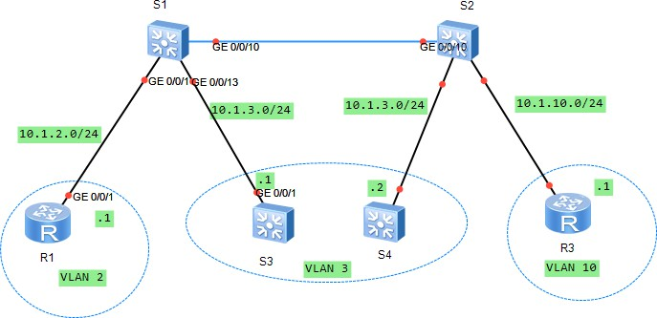

*Figure 1: Network Topology*

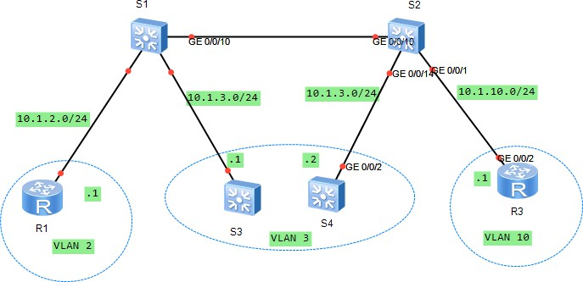

*Figure 2: Network Topology*

# CMD’S

1. Switch 1 CMD’s

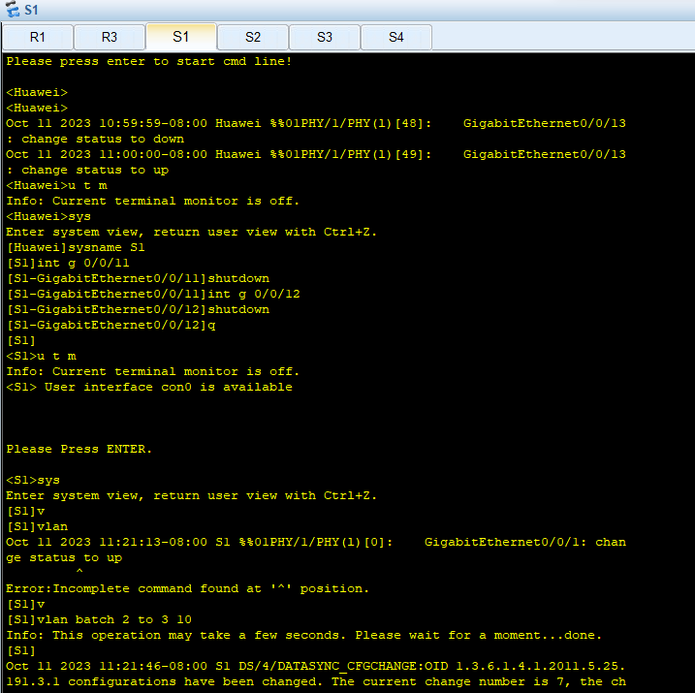

*Figure 3: Switch 1 CMD*

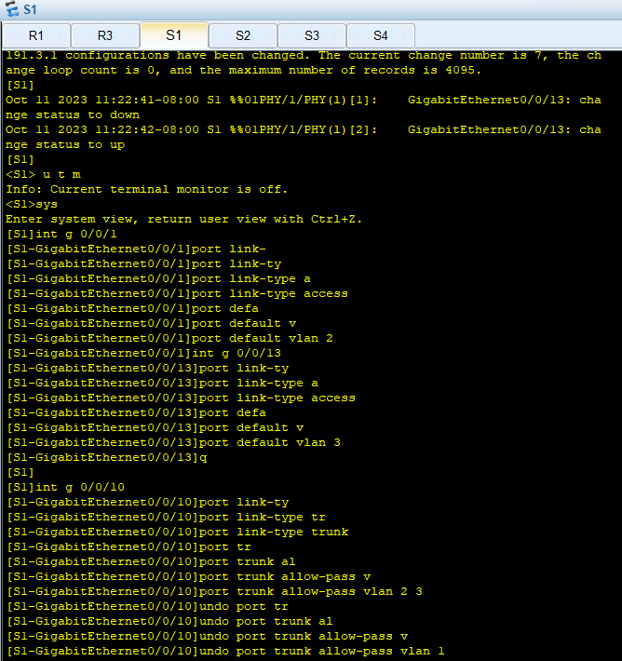

*Figure 4: Switch 1 CMD*

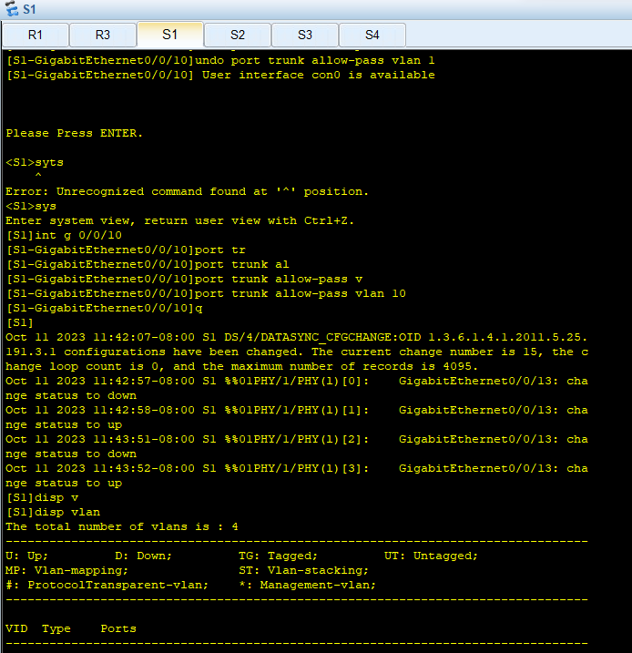

*Figure 5: Switch 1 CMD*

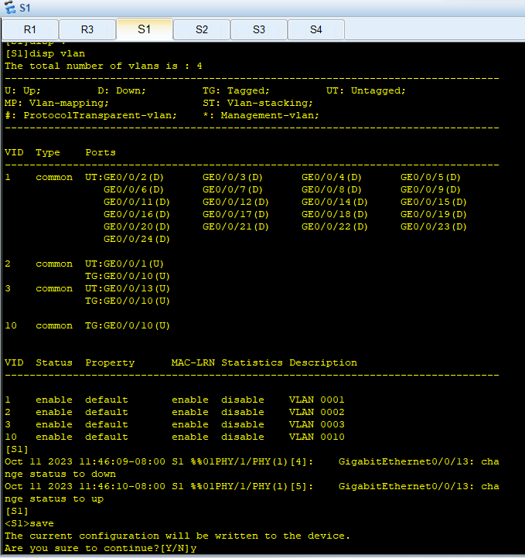

*Figure 6: Switch 1 CMD*

1. Switch 2 CMD’s

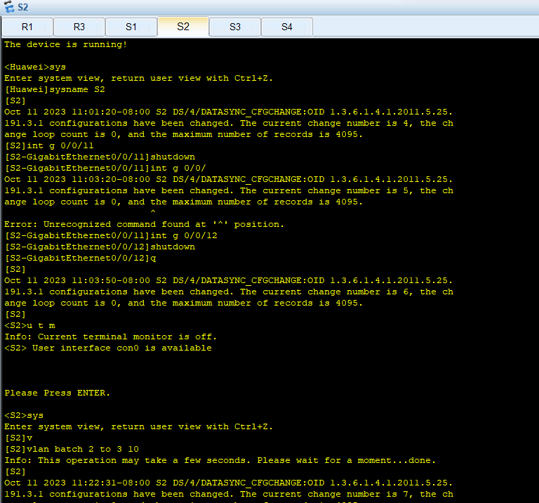

*Figure 7: Switch 2 CMD*

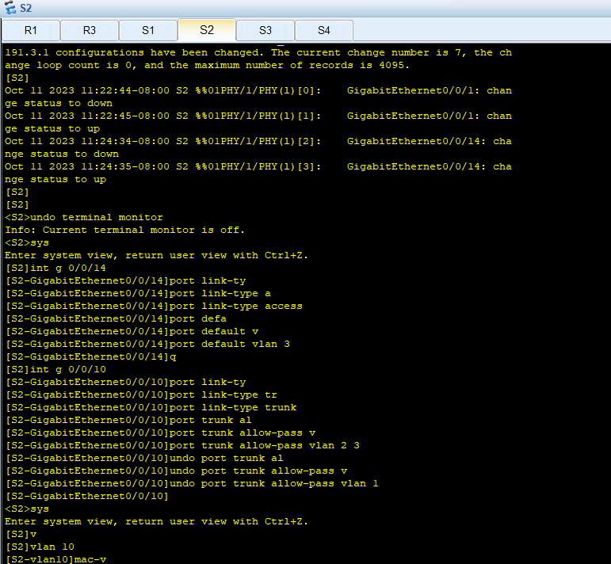

*Figure 8: Switch 2 CMD*

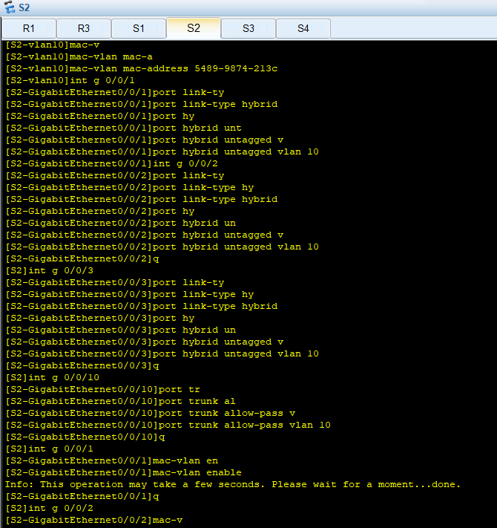

*Figure 9: Switch 2 CMD*

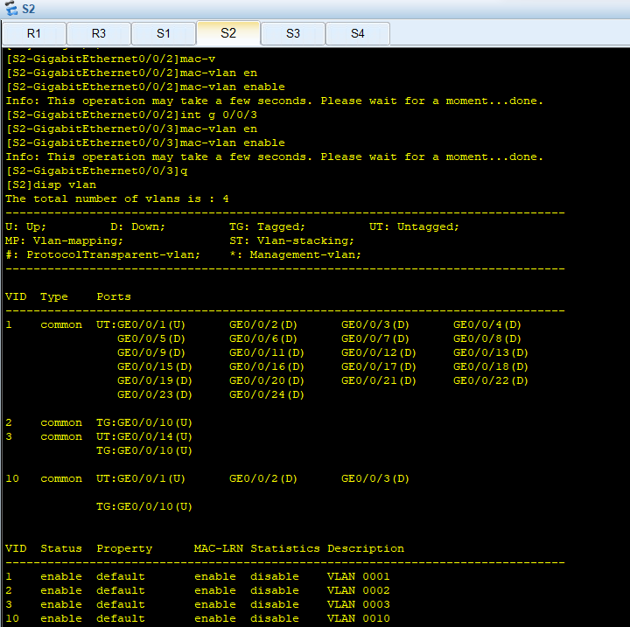

*Figure 10: Switch 2 CMD*

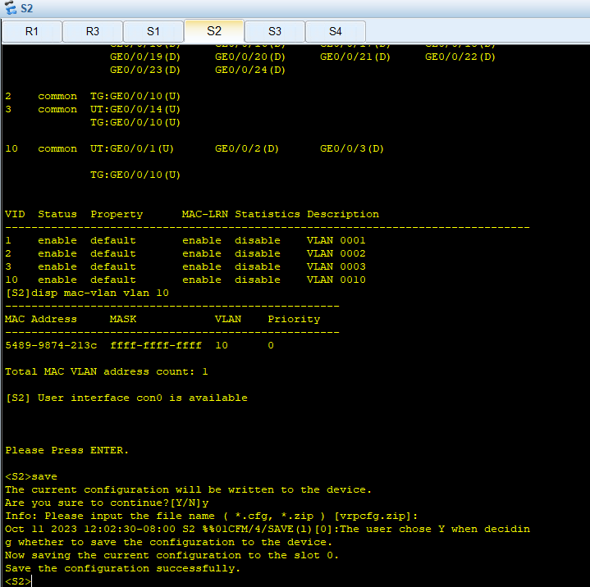

*Figure 11: Switch 2 CMD*

1. Switch 3 CMD’s

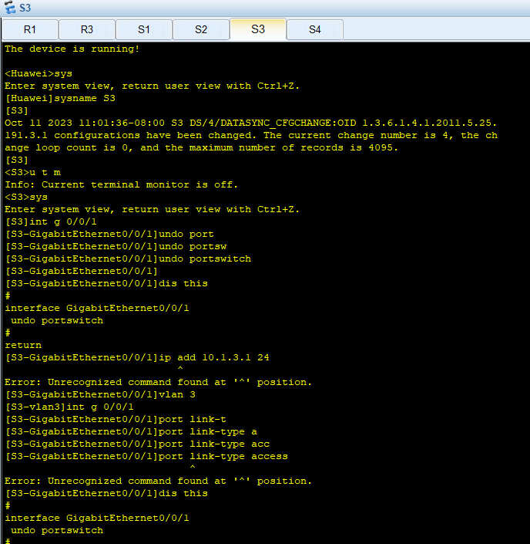

*Figure 12: Switch 3 CMD*

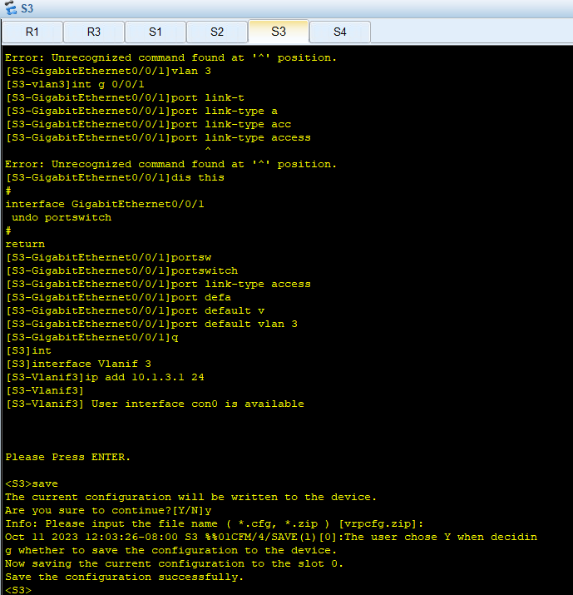

*Figure 13: Switch 3 CMD*

1. Switch 4 CMD’s

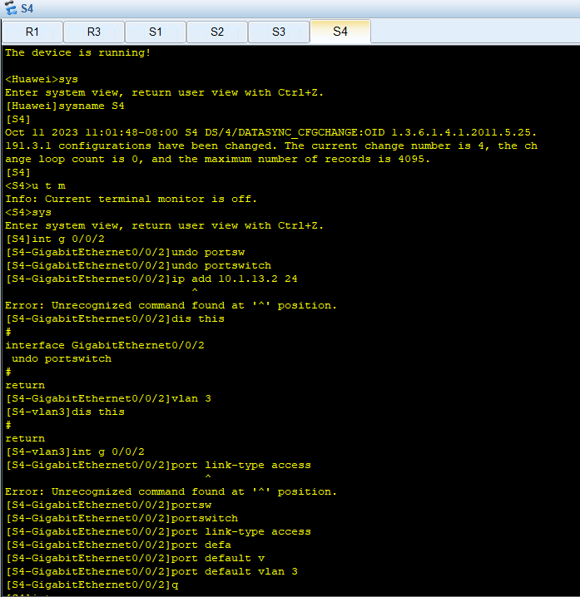

*Figure 14: Switch 4 CMD*

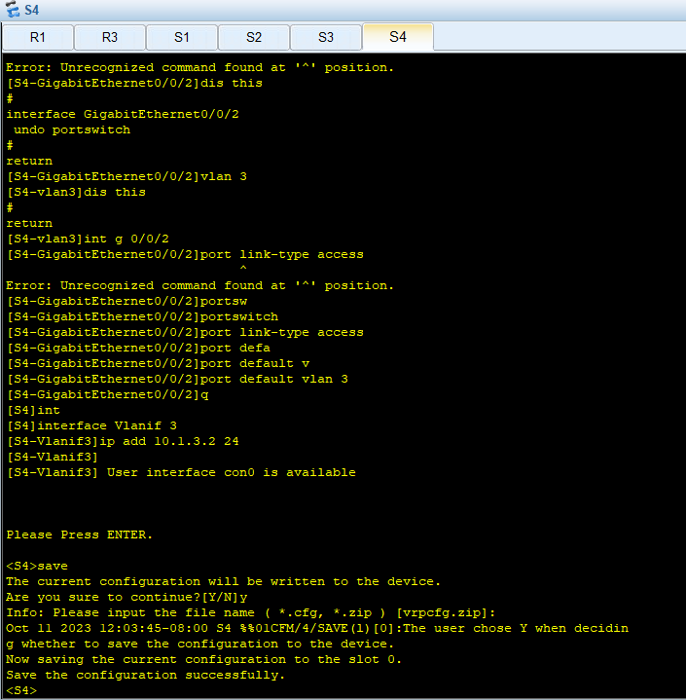

*Figure 15: Switch 4 CMD*

1. Router 1 CMD’s

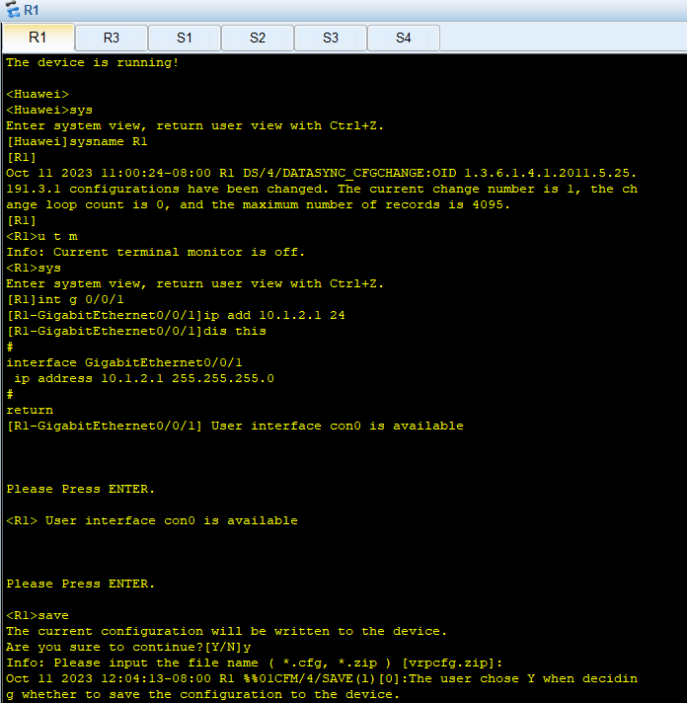

*Figure 16: Router 1 CMD*

1. Router 3 CMD’s

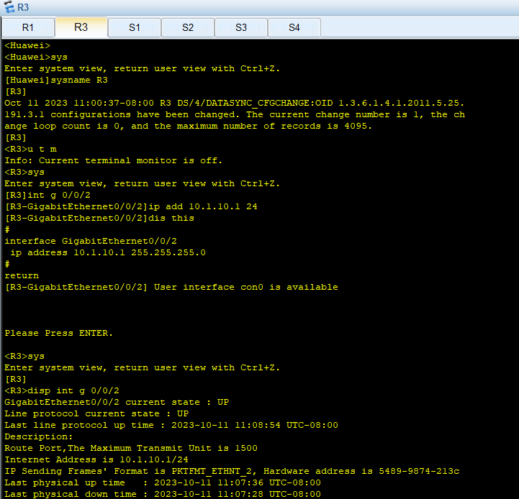

*Figure 17: Router 3 CMD*

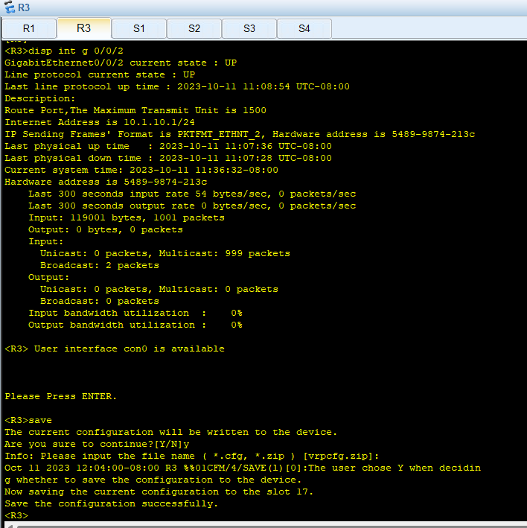

*Figure 18: Router 3 CMD*

# VERIFICATION

* No. 1

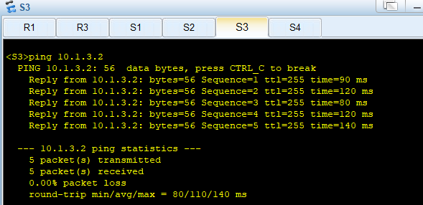

*Figure 19: Ping S4 from S3*

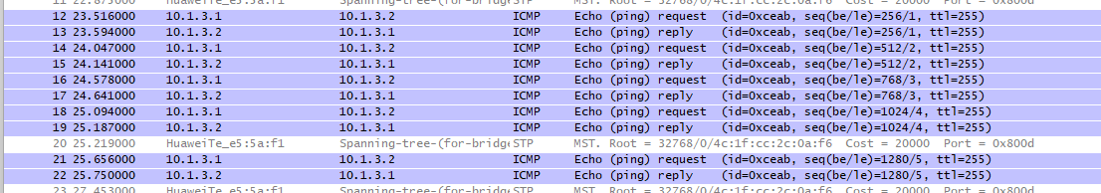

*Figure 20: Wireshark Output*

* No. 2

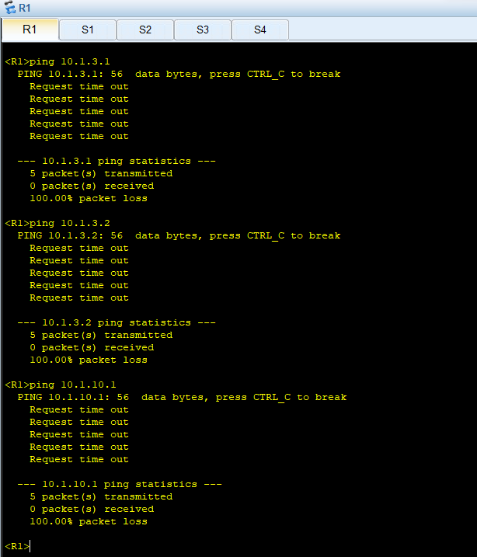

*Figure 21: Pinging Other Devices from R1*

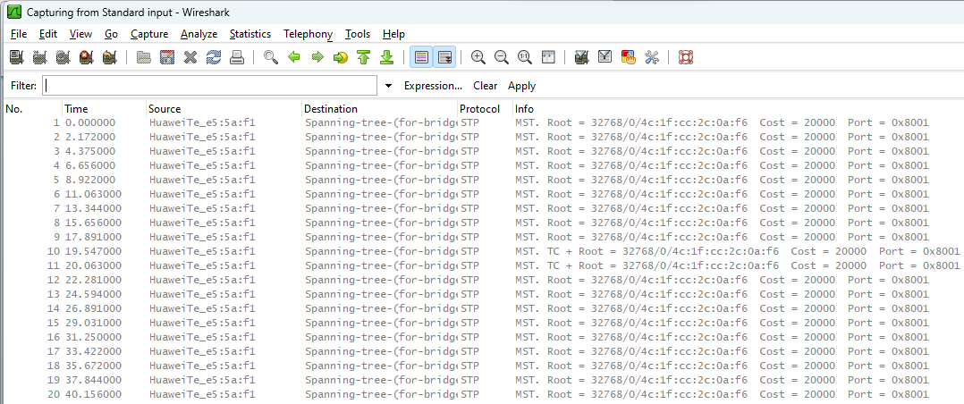

*Figure 22: Wireshark Output*

* No. 3

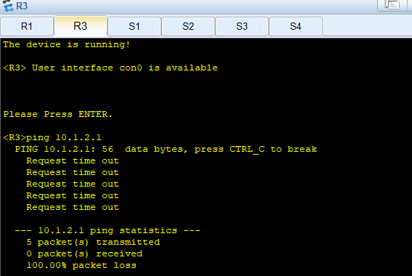

*Figure 23: Ping R1 from R3*

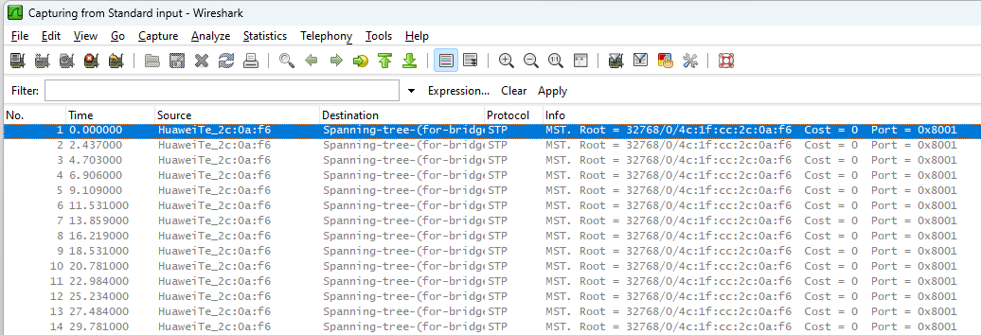

*Figure 24: Wireshark Output*

* No. 4

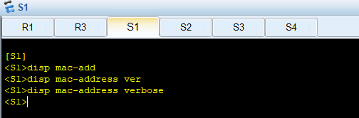

*Figure 25: S1 CMD*

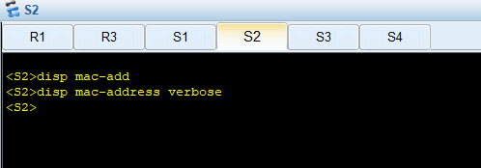

*Figure 26: S2 CMD*

# CONCLUSION

In conclusion, this lab achieved its goals. I learned important things about Ethernet and VLANs on Huawei switches. Now I know how to make VLANs, set up different types of ports, use MAC addresses for VLANs, and check if everything works. This helps network experts make networks work better and safer.

I also gained a lot of experience on how the network works like we cannot ping devices from different VLANs because devices from different VLAN cannot communicate via layer 2 they can only communicate via layer 3.